

**ARBA MINCH UNIVERSITY**

**SAWLA CAMPUS**

**COLLEGE OF ENGINEERING AND AGRO-INDUSTRIAL TECHNOLOGY**

**DEPARTMENT OF ELECTROMECHANICAL ENGINEERING**

**DESIGN OF LINE FOLLOWING ROBOT WITH OBSTACLE DETECTION**

**B.Sc. THESIS RESEARCH**

**BY**

**NAME OF STUDENT ID NUMBER**

1. NATNALE TESERA…………………………………...…. RAMIT/1230/09
2. TSADKAN YOHANNES…………………………………. RAMIT/1563/09
3. MESFIN MAMUYE………………………………….….…RAMIT/1071/09
4. TSEGAYE G/SELASSIE…………………………………. RAMIT/1575/09
5. SINTAYEHU TAMRAT…………………………………. RAMIT/1426/09

**ADVISOR:** Mr. ABEL C.

**September, 2021**

# 

# APPROVAL PAGE

Title: __________________________________________________________________

Student Name: Signature, Date:

_______________________________ _____________________

_______________________________ _____________________

_______________________________ _____________________

_______________________________ _____________________

_______________________________ _____________________

**Approved by the examining committee members:**

Name Academic Rank Signature Date

Advisor: ________________ ________________ ___________ ___________  
Examiner1: ________________ ________________ ___________ ___________  
Examiner2: ________________ ________________ ___________ ___________ Examiner3: ________________ ________________ ___________ _________

Name Signature Date

DGC Chairperson: ______________________ _______________ ____________

# Declaration

We, declare that this graduate thseis  is our original work, has not been submitted to this or any any other universties for the fulfillment of a degree, and all source  of the materials used for the thesis have been fully acknowledged.

Declared By

Name ID Signature

Natnale Tesera RAMIT/1230/09 ……………….

Tsadkan Yohannes RAMIT/1563/09 ………………..

Mesfin Mamuye RAMIT/1071/09 ……………….

Tsegaye G/Selassie RAMIT/1575/09 ……………….

Sintayehu Tamrat RAMIT/1426/09 ……………….

Advisor Name

Abel Chernet  --------------------

Signature

# ACKNOWLEDGEMENT

First of all, we would like to thank our mighty GOD for everything that he has done for us in our life. We would like to express our happiness and appreciation to all those who gave us the possibility to complete this thesis. We are highly grateful to our adviser Mr. Abel.C for his guidance and constant supervision as well as for providing necessary information regarding to complete this thesis. Next, we would also thank our family who give directly or indirectly helped and support us to finish this thesis. Last but not the least we would like to thank our friends and other family for their help in every way for the success of this thesis.

# ABSTRACT

Robot is a machine that can carry out complex series of actions automatically when once programmed by computer. There are five types of robots which are Pre-Programmed Robots, Humanoid Robots, Autonomous Robots, Tele operated Robots and Augmenting Robots. Autonomous robots are intelligent robots capable of performing tasks in the world by themselves, without explicit human control. Line following robot with obstacle detection is a type of autonomous robot that follows defined path by detecting nearby obstacle. In our thesis we design line following robot with obstacle detection using IR and ultrasonic sensors integrated with Arduino microcontroller. IR sensor used to detect the path drawn in the floor and the ultrasonic sensor used to detect the obstacle. We also add buzzer for alarm system to notify when the obstacle is present. For circuit simulation we use Proteus Design Suite integrated with Arduino program to observe the overall circuit of the thesis. Webots software also is used for visual simulation using e-puck Webots library. The obstacles and the patch designed using Webots and it’s clearly visible in the simulation.

**Keywords:** Autonomous robots; Line following robot; IR sensor; Ultrasonic sensor; Arduino; Proteus suite; Webots software.

# ACRONYMS

DC Direct Current

EMF Electromagnetic Field

IC Integrated Circuit

IR Infra-Red

LED Light Emitting Diode

PCB printed circuit board

PWM Pulse-Width Modulation

RPM Revolutions per Minute

SRAM Static Random Access Memory

LCD liquid crystal display

EEPROM electrical erasable and programmable read only memory

PIR passive infra-red

GND ground

BJTBipolar Junction Transistor

MOSFET metal-oxide-semiconductor field-effect transistor

IDE Integrated development environment

# Table of Contents

APPROVAL PAGE i

Declaration ii

ACKNOWLEDGEMENT iii

ABSTRACT iv

ACRONYMS v

Table of Contents vi

List of Figures viii

List of Tables ix

CHAPTER ONE 1

1 INTRODUCTION 1

1.1 Background 1

1.2 Problem statement 2

1.3 Objectives 3

1.3.1 General Objective 3

1.3.2 Specific Objectives 3

1.4 Scope of the study 3

1.5 Significance 3

1.6 Chapter Outline 4

CHAPTER TWO 5

2 LITERATURE REVIEW 5

CHAPTER THREE 7

3 METHODOLOGY AND SYSTEM DESIGN 7

3.1 Overall System Block Diagram of Line Follower Robot 7

3.2 Hardware component 8

3.2.1 The input Section 8

3.2.2 The Control Section 16

3.2.3 The Output Section 18

3.3 Software component 24

3.3.1 Arduino IDE 24

3.3.2 Proteus Design Suite 25

3.3.3 Webots 26

3.4 Mathematical Modeling 27

3.4.1 Kinematic Model of line follower robot with obstacle detection 27

CHAPTER FOUR 30

4 Result and Discussion 30

4.1 Flow chart 30

4.2 General Operation of the Circuit 31

4.3 Programming and Simulation 32

4.3.1 Arduino Working Logic 32

4.3.2 Proteus Simulation 33

4.3.3 Webots simulation 34

4.4 Implementation of the project 37

4.4.1 Component used 37

CHAPTER FIVE 39

5 CONCLUSION AND RECOMMENDATION 39

5.1 Conclusion 39

5.2 Recommendations 40

References 41

# List of Figures

Figure 3.1 Block diagram of line follower robot 7

Figure 3.2 HC-SR-04 ultrasonic sensor 8

Figure 3.3 Ultrasonic emitting the signal and receiving the echo 10

Figure 3.4 Infra-Red Light Sensor 11

Figure 3.5 Infrared LED of Emitter and Receiver 13

Figure 3.6 Arrangement of sensors 14

Figure 3.7 Both sensor sense nothing or on the black portion 14

Figure 3.8 The right sensor on the black line 15

Figure 3.9 The left sensor on the white line 15

Figure 3.10 Arduino UNO interface board 17

Figure 3.11 L298N Motor driver 19

Figure 3.12 L298N Motor Driver Module Working of H-Bridge Case 1 20

Figure 3.13 L298N Motor Driver Module Working of H-Bridge Case 2 21

Figure 3.14 L298N Motor Driver Module Working of H-Bridge Case 3 21

Figure 3.15 L298N Motor Driver Module Pulse Width Modulation (PWM) technique 22

Figure 3.16 Chassis and Wheels of the prototype 23

Figure 3.17 A Piezo buzzer 24

Figure 3.18 Kinematic Model of line follower robot with obstacle detection 27

Figure 4.1 Flow chart 30

Figure 4.2 Overall circuit diagram 32

Figure 4.3 Proteus simulation 34

Figure 4.4 E-puck 35

Figure 4.5 Path of the robot 35

Figure 4.6 Obstacle 36

Figure 4.7 Webots simulation 36

Figure 4.8 Line following robot with obstacle detection 38

# List of Tables

Table 3‑1 L298N Module Pin out Configuration 19

Table 4‑1 Working logic of an Arduino 33

Table 4‑2 Component used 37

# CHAPTER ONE

# INTRODUCTION

## Background

The term robotwas first introduced into our vocabulary by the Czech playwright Karel Capek in his 1920 play Rossum’s Universal Robots, the word robota being the Czech word for work. Since then the term has been applied to a great variety of mechanical devices, such as Tele operators, underwater vehicles, autonomous land rovers, etc [1]. There are five types of robots which are Pre-Programmed Robots, Humanoid Robots, Autonomous Robots, Tele operated Robots and Augmenting Robots [2].

Pre-programmed robots operate in a controlled environment where they do simple, monotonous tasks. An example of a pre-programmed robot would be a mechanical arm on an automotive assembly line. The arm serves one function to weld a door on, to insert a certain part into the engine, etc. and its job is to perform that task longer, faster and more efficiently than a human. Humanoid robots are robots that look like and/or mimic human behavior. These robots usually perform human-like activities (like running, jumping and carrying objects), and are sometimes designed to look like us, even having human faces and expressions. Two of the most prominent examples of humanoid robots are Hanson Robotics’ Sophia and Boston Dynamics’ Atlas.

Tele operated robots are semi-autonomous bots that use a wireless network to enable human control from a safe distance. These robots usually work in extreme geographical conditions, weather, circumstances, etc. Examples of Tele operated robots are the human-controlled submarines used to fix underwater pipe leaks during the BP oil spill or drones used to detect landmines on a battlefield. Augmenting robots either enhance current human capabilities or replace the capabilities a human may have lost. The field of robotics for human augmentation is a field where science fiction could become reality very soon, with bots that have the ability to redefine the definition of humanity by making humans faster and stronger. Some examples of current augmenting robots are robotic prosthetic limbs or exoskeletons used to lift hefty weights.

Autonomous robots operate independently of human operators. These robots are usually designed to carry out tasks in open environments that do not require human supervision. They are quite unique because they use sensors to perceive the world around them, and then employ decision-making structures (usually a computer) to take the optimal next step based on their data and mission. An example of an autonomous robot would be the Roomba vacuum cleaner, which uses sensors to roam freely throughout a home. A Line Follower Robot, as the name suggests, autonomous robot, which follow a visual line embedded on the floor or ceiling. Usually, the visual line is the path in which the line follower robot goes and it will be a black line on a white surface but the other way (white line on a black surface) is also possible. Large line follower robots are usually used in industries for assisting the automated production process. They are also used in military applications, human assistance purpose, delivery services etc. [3].

In our thesis we design line following robot with obstacle detection. In addition to line following the robot can also detect the obstacle in the path to stop the robot when the obstacle is in the way of the robot. These robots can be used as automated equipment carriers in industries replacing traditional conveyer belts. Line following robot with obstacle detection has a lot of applications in industry, automobile, domestic, guidance etc. In industry these robots can be used as automated equipment carriers replacing traditional conveyer belts. They can be used as automatic cars running on roads with embedded magnets. They can be used domestically like home floor cleaning purposes. They can be used in public places like shopping malls, museums to provide path guidance.

## Problem statement

Robot becomes important mainly in industries for transportation, material handling, carry products etc. This daily routine job is actually tedious and time consuming. The line follower robot with obstacle detection performs this type of task in cost effective, flexible, safe and provide 24 Hour Service. At the same time, it will reduce employee payment cost, time, and human power.Where in industry this task can be a repetitive and boring for human beings also operating for long hours without resting is difficult to human beings. We improved this work by replacing human labor by line following robot with obstacle detection.

## Objectives

### General Objective

The general objective of this thesis is to design a line following robot with obstacle detection system.

### Specific Objectives

* To use IR and ultrasonic sensor for the line following and obstacle detection.
* To program line following and obstacle detection code with Arduino IDE
* Design line following and obstacle detection circuit in Proteus
* To integrate Arduino program with Proteus for circuit simulation
* To simulate line follower with obstacle detection robot with Webots software using e-puck
* To implement prototype for line following robot with obstacle detection

## Scope of the study

In our thesis we design line follower robot with obstacle detection that is capable of detecting and following black line on the floor which also can detect the obstacle in the path to stop in order to protect the robot from collision. We design the circuit simulation with Proteus and visual design by Webots software. We also try to implement and test the prototype of the robot with available materials.

Since, in order to follow the black line the floor must be black and white unless it might not follow the black line properly. Our thesis is not applicable on difficult geographical area which is not smooth surface for drawing the black line. It is not applicable on vertical load transportation. In this paper we don’t consider detail mathematical model and mechanical design.

## Significance

Our thesis can be applied on many different areas like in factory for transportation of end product from final processing sector to storage house, and it is also applicable on Industrial Applications: These robots can be used as automated equipment carriers in industries replacing traditional conveyer belts.

This thesis is useful in many ways it will reduce the cost paid for labor, it will facilitate in mass production of product, it will reduce accident risk on the job and increase stock management on the factory further more speed, accuracy, reliability or endurance can be performed far better by a robot than a human. Robot can work tirelessly as long as it gets power supply.

## Chapter Outline

Chapter two: literature review

Chapter three: methodology and system design with block diagram.

Chapter four: result and discussion with brief flow chart explanation.

Chapter five: overall conclusion and recommendation of the thesis.

# CHAPTER TWO

# LITERATURE REVIEW

Faiza Tabassum et al. [4] design Obstacle Avoiding Robot. The robot detects obstacles with the help of three ultrasonic distance sensors to measures the distance to surrounding objects. Although the thesis is started with a single ultrasonic sensor, two more sensors is added since the robot had blind spots in its right and left direction for which it was having collision while maneuvering. The work concentrates on coordinating multiple ultrasonic sensors for Arduino maneuvering without collision and also maintaining a minimum travel distance. They used three ultrasonic distance sensors to detect obstacles. The Arduino board was selected as the microcontroller platform and its software counterpart, Arduino Software, was used to carry out the programming. The integration of three ultrasonic distance sensors provides higher accuracy in detecting surrounding obstacles. Being a fully autonomous robot, it successfully maneuvered in unknown environments without any collision. In this thesis the robot has no guided path which means the starting point and destination points are not defined. Beside that this robot uses three ultrasonic sensors but in our thesis we use one ultrasonic sensor, using three ultrasonic is a kind of coasty. The basic aim in this thesis is only avoidance of obstacle.

The Design and Implementation of Line Follower Robot using Arduino Microcontroller presented by Quazi Taif Sadat et al [5]. It detects and follows back and forth specified line with a concentrated color. Here, more than one IR sensor used to detect the line and keep the robot strictly on the track. DC motors controls the movement of the wheels of the robot. Arduino Uno R3 interface has been used to perform and implement algorithms to control the speed and direction of the robot. It can be used industrial automated equipment carriers, small household applications, tour guides in museums and other similar applications. In this work, ultrasonic sensor is not used for obstacle detection, which it uses guided path by following black line drown to the ground which is similar to our thesis, and differed in not made for obstacle detection, which means they are not obligated to use ultrasonic sensor for obstacle detection and this will reduce for them the money expense.

S. V. Anupoju et al.,[6] designed line follower robot using 5 sensors. They focused on the designing efficient lightweight line following robot using 5 sensors which makes the robot can move in complex paths. IR sensors used to track the path which need black line draw on the floor but the three extra sensors makes connection process complex. They don’t have obstacle detection mechanism.

The use of computer controlled line follower robots in public transport [7] Mobile robots, is the form of vehicles that are able to move along the lines in the roads specially designed as they are taught to follow lines, thus creating a continuous flow in public transport traffic as the robots cannot go out of the roads assigned to them. These robots will be in touch with the host system using the communication modules sending instant data for road condition and the vehicle’s current state. Hence, the operator at the host will be able to access the information about the vehicle’s current state, temperatures, moisture, speed, location, curves and stops whether there are objects in front of the vehicle and the distance between the vehicle and the object in meter. The data sent from the vehicle will be analyzed by the operator and used to prevent the possible dangers. The vehicle having the information of a coming curve will slow down to the speed defined before and then accelerate to the speed it had before. In this work IR and obstacle sensor are not used for line tracking and obstacle avoiding, respectively.

Md. Majedur Rahman et al. [8] uses IR sensor to follow certain black line and PIC16F676 for microcontroller. The robot uses two motor wheels and consists of infrared sensors on the bottom to detect black tracking line. It traces the line position by the aid of the IR sensors. As the sensors detect dark surface, output of comparator, LM323 is low and for bright surface high output. Microcontroller PIC16F676 controls the gear motors and LM323 comparators control the motor drives. In this work they use PIC microcontroller which is can be hard to program and debug as the PIC family becomes rarely in use nowadays in addition they only design robot that follow the black line and they don’t consider the obstacle.

# CHAPTER THREE

# METHODOLOGY AND SYSTEM DESIGN

## Overall System Block Diagram

IR Sensors

Arduino Uno

Power Supply

Motor Driver (L293D)

Ultrasonic sensor

Buzzer

Power Supply

Figure . Block diagram of line follower robot

## Hardware component

These sections consists the following parts.

* Power supply: Provide power for the sensors, controller and output device.
* The input section: Provides interface of sensors with the Arduino. This section includes Ultrasonic and IR sensors.
* The control section: Provides the programming and control using the Arduino
* The output section: Provides interface of Arduino which contain motor driver, dc geared motors and passive buzzer.

The integration of the sections is producing the system which is more or less can be divided into two phase. Where the first phase is the monitoring system and the second phase is the output of the system. The sensor and Arduino are monitoring system which is in the first phase of the system. The motors are the second phase of the output of line follower robot system.

### The Input Section

#### Ultrasonic Sensor

An ultrasonic sensor is an instrument that measures the distance to an object using ultrasonic sound waves. An ultrasonic sensor uses a transducer to send and receive ultrasonic pulses that relay back information about an object’s proximity.  High-frequency sound waves reflect from boundaries to produce distinct echo patterns [9].

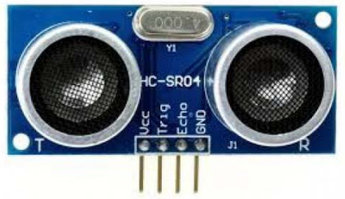

Figure . HC-SR-04 ultrasonic sensor

In the above image show the HC-SR-04 ultrasonic sensor which has transmitter, receiver. The pin configuration is

* VCC – +5 V supply
* TRIG – Trigger input of sensor. Microcontroller applies 10 us trigger pulse to the HC-SR04 ultrasonic module.
* ECHO–Echo output of sensor. Microcontroller reads/monitors this pin to detect the obstacle or to find the distance.
* GND – Ground

Sound is a mechanical wave traveling through the mediums, which may be a solid, or liquid or gas. Sound waves can travel through the mediums with specific velocity depends on the medium of propagation. The sound waves which are having high frequency reflect from boundaries and produce distinctive echo patterns.

Features of an Ultrasonic Sensor

1. Supply voltage: 5V (DC).
2. Supply current: 15mA.
3. Modulation frequency: 40Hz.
4. Output: 0 – 5V (Output high when obstacle detected in range).
5. Beam Angle: Max 15 degrees.
6. Distance: 2 cm – 400 cm.
7. Accuracy: 0.3cm.
8. Communication: Positive TTL pulse.

**Ultrasonic Sensor Working Principle**

Ultrasonic sensors emit short, high-frequency sound pulses at regular intervals. These propagate in the air at the velocity of sound. If they strike an object, then they reflected back as an echo signals to the sensor, which itself computes the distance to the target based on the time-span between emitting the signal and receiving the echo.

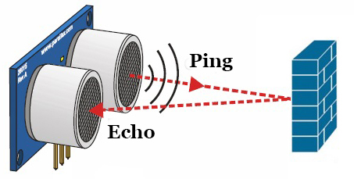

Figure . Ultrasonic emitting the signal and receiving the echo

**Distance calculation of ultrasonic sensor**

To measure the specific distance from your sensor, this can be calculated based on this formula:

To measure distance,

The speed of sound waves is 343 m/s. Then,

Total distance is divided by 2 because signal travels from HC-SR04 to object and returns to the module HC-SR-04.

In our thesis we use one HC-SR-04 ultrasonic sensor to detect obstacle and measure the distance of obstacle. This economical sensor provides 2cm to 400cm of non-contact measurement functionality with a ranging accuracy that can reach up to 3mm. Each HC-SR04 module includes an ultrasonic transmitter, a receiver and a control circuit. If the obstacle distance is less than 30 cm the Arduino microcontroller force to stop the motors. When the obstacle clears from the path the robot can continue to follow the line.

#### IR Sensor Module

The infrared sensor, also known as IR sensor, is a device that detects reflected light and emits infrared light. It can therefore differentiate between black and white or dark and light. There are many types of infrared sensor, such as the ones found in TV remote controls, object detection or even for measuring a person´s heart rate. The infrared sensor that we will be using is digital and will return 1 whenever white is detected, and 0 when black is detected [10].

The IR sensor module consists mainly

1. IR Transmitter
2. Photodiode Receiver
3. LM393 Comparators IC
4. Variable Resistor (Trim pot
5. Power LED
6. Output LED.

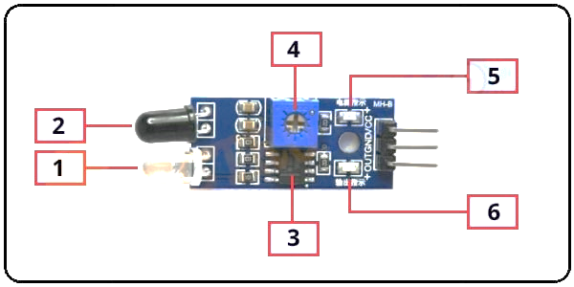

Figure . Infra-Red Light Sensor

1. **Infrared LED or IR Transmitter:**

**An IR LED is a specially designed light-emitting diode (LED), its emitting infrared rays. Infrared ray’s wavelength ranging is from 700 nm to 1 mm. normally an IR LED looks like a normal LED. It has two terminals, the longer one is Positive and the smaller one is negative. When IR LED operated at a power supply, it starts emitting infrared rays.**

1. **Photodiode Receiver or IR Receiver:**

**Normally IR receivers are photodiode. It is a semiconductor which has a P-N junction. A photodiode is capable to detect infrared rays. It’s operated in Reverse Bias. The photodiode has very High resistance in the absence of infrared rays and becomes low when infrared rays fall on it. Also, it has two terminals, the longer one is Positive and the smaller one is negative.**

1. **LM358 Operational Amplifier (comparator)**

**LM358 is an Operational Amplifier (Op-Amp) is used as voltage comparator in the IR sensor. The comparator will compare the threshold voltage set using the preset (pin2) and the photodiode’s series resistor voltage (pin3).**

**Photodiode’s series resistor voltage drops > Threshold voltage = Op amp output is High Photodiode’s series resistor voltage drops < Threshold voltage = Op amp output is Low**

**When Op amp's output is high the LED at the Op amp output terminal turns ON (Indicating the detection of Object).**

1. **Variable Resistor (Trim pot)**

**IR sensor has an onboard variable resistor (potentiometer). This variable resistor is a 10k preset. It is used to set the range of operation. Rotate the preset knob to adjust the detection distance, the effective operation ranges 2-10 cm. If the preset knob rotated clockwise, the detection range will be increased. If it rotated counterclockwise, the detection range will be decreased.**

1. **Power LED**

**This onboard LED indicates the IR Sensor power supply is ON or OFF. When we turn on the IR Sensor power supply this RED LED is also turn on.**

1. **Output LED**

**When infrared reflected back to the IR receiver and the sensor detects an obstacle the green LED lights up. So, the Green LED use to indicate the sensor senses an obstacle.**

**Use of Comparator in IR sensor**

As above we see that two inputs are required for comparator. The potentiometer is used to calibrate the output of the sensor according to the requirement. One input is from photo-receiver (like photo-diode), other is generated by us using potentiometer. The second voltage is also called as reference voltage for that sensor. Setting of reference voltage (Vref) we can vary reference voltage by using potentiometer, such that it can vary from 0 V to Vcc. We set reference voltage as mean value of the sensor inputs measured with and without light [10].

**Working Principle of IR Sensor**

The principle of an IR sensor working as an Object Detection Sensor can be explained using the following figure. An IR sensor consists of an IR LED and an IR Photodiode; together they are called as Photo – Coupler or Opt – Coupler. When the IR transmitter emits radiation, it reaches the object and some of the radiation reflects back to the IR receiver. Based on the intensity of the reception by the IR receiver, the output of the sensor is defined.

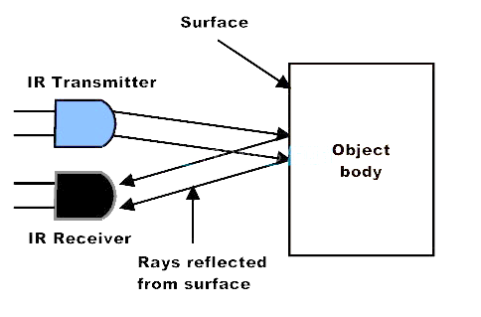

Figure . Infrared LED of Emitter and Receiver [10]

IR sensor is the main component used in our thesis. We use two obstacle detection IR sensors

**Arrangement of Sensors**

An array of sensors arranged in a straight row pattern is bolted under the front of the robot. It is used to locate the position of line below the robot. We can use any number of sensors. If we have lesser number, then our robot movement is not smooth and it may face problems at sharp turns. If we used higher number of sensors robot movement will become smooth and reliable for sharp turns, only drawbacks it requires complex programming for Arduino and requires more hardware. Thus we choose two sensors. The distance between each sensor depend on:-

* The number of sensors used
* The width of straight line (distance between sensors should be less than width of line).
* The distance between sensors may not be constant (it depends on the logic).

Figure . Arrangement of sensors

There are three conditions of arrangement of the sensors, these conditions are:

* **Both sensors out of the Black line**: The line is straight and both sensors are in white portion. So the robot must in ‘Forward’ direction. Hence, both wheels (Left and Right) must consecutively move in forward direction.

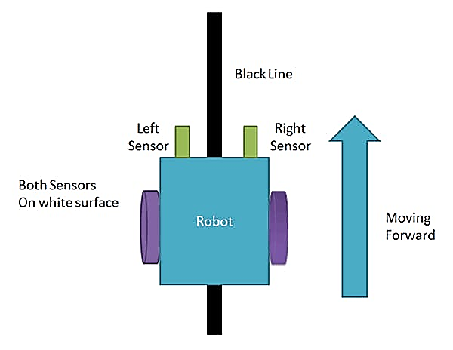

Figure . Both sensor sense nothing or on the black portion [11]

* **Right sensor on the Black Line:** The right sensor is on the black line and we can see that the robot needs to move in the ‘Right’ direction (turns to the right side). Hence, left wheel must move in forward direction and Right wheel must be stopped (or move backwards).

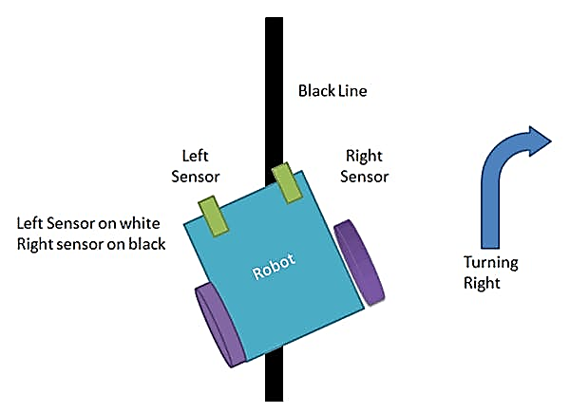

Figure . The right sensor on the black line [11]

* **Left sensor on the Black Line:** The left sensor is on the black line and we can see that the robot needs to move in the ‘Left’ direction (turns the left side). Hence, Right wheel must move in forward direction and Left wheel must be stopped (or move backwards).

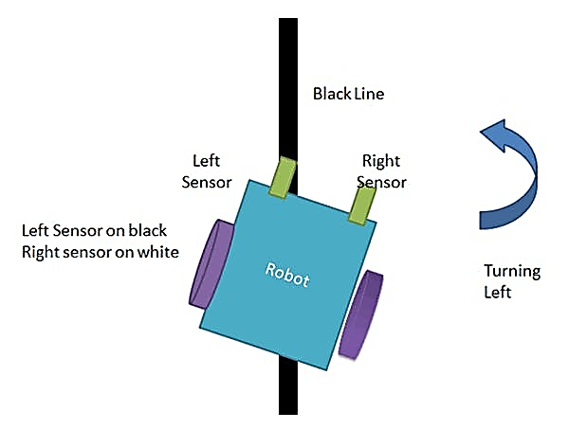

Figure . The left sensor on the white line [11]

In our thesis we use two object detection IR sensor module to detect the floor color. The sensor detects both black and white color.

#### Power Supply (Batteries)

The power supplying used for to a robot, is rechargeable batteries are usually the best ones. A motor runs well between 9 to 12 volts, and alkaline batteries, lithium ion, nickel cadmium or Zinc carbon batteries can be used. The appropriate series parallel combination can be used to provide more power than a standard battery can provide [12].

### The Control Section

#### Arduino

Arduino is an open-source electronics platform based on easy-to-use hardware and software. Arduino boards are able to read inputs - light on a sensor, a finger on a button, or a Twitter message and turn it into an output, activating a motor, turning on an LED, publishing something online. You can tell your board what to do by sending a set of instructions to the microcontroller on the board. To do so you use the Arduino programming language (based on Wiring), and the Arduino Software (IDE), based on Processing [9].

Arduino is composed of two major parts:

1. The Arduino board, which is a piece of hardware you work on when you build your objects.
2. The Arduino IDE, which is a piece of software you run on your computer. You use the IDE to create a sketch (a small computer program) that you upload to the Arduino board. [13]

The Arduino Uno is a microcontroller board based on the ATmega328. It has 14 digital input/output pins (of which 6 can be used as PWM outputs), 6 analog inputs, a 16 MHz ceramic resonator, a USB connection, a power jack, an ICSP header, and a reset button. It contains everything needed to support the microcontroller; simply connect it to a computer with a USB cable or power it with an AC-to-DC adapter or battery to get started. Central to the Arduino interface board, shown in Figure 3.10is an onboard microcontroller.

Specifications of the Arduino UNO R3 are as follows:

* + Microcontroller: ATmega328
  + Operating Voltage: 5 V
  + Input Voltage (recommended): 7–12 V
  + Input Voltage (limits): 6–20 V
  + Digital I/O Pins: 14 (of which 6 provide PWM outputs)
  + Analog Input Pins: 6
  + DC Current per I/O Pin: 40 mA
  + DC Current for 3.3 V Pin: 50 mA
  + Flash Memory: 32 KB of which 0.5 KB is used by the bootloader
  + SRAM: 2 KB (ATmega328)
  + EEPROM: 1 KB (ATmega328)
  + Clock Speed: 16 MHz

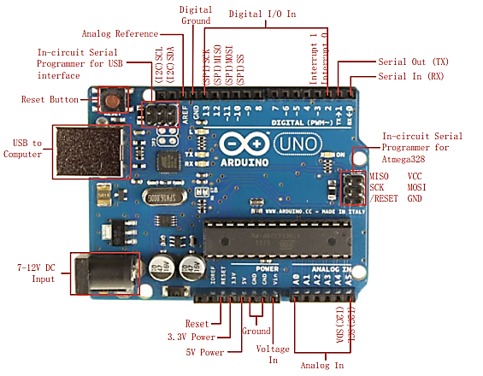

Figure . Arduino UNO interface board [9]

In our thesis we prefer Arduino UNO R3 as microcontroller because of

**Inexpensive**: Arduino boards are relatively inexpensive compared to other microcontroller platforms. The least expensive version of the Arduino module can be assembled by hand, and even the pre-assembled Arduino modules cost less than $50.

**Cross-platform**: The Arduino Software (IDE) runs on Windows, Macintosh OSX, and Linux operating systems. Most microcontroller systems are limited to Windows.

**Simple, clear programming environment**: The Arduino Software (IDE) is easy-to-use for beginners, yet flexible enough for advanced users to take advantage of as well. For teachers, it's conveniently based on the Processing programming environment, so students learning to program in that environment will be familiar with how the Arduino IDE works.

**Open source and extensible software**: The Arduino software is published as open source tools, available for extension by experienced programmers. The language can be expanded through C++ libraries, and people wanting to understand the technical details can make the leap from Arduino to the AVR C programming language on which it's based. Similarly, you can add AVR-C code directly into your Arduino programs if you want to.

**Open source and extensible hardware**: The plans of the Arduino boards are published under a Creative Commons license, so experienced circuit designers can make their own version of the module, extending it and improving it. Even relatively inexperienced users can build the breadboard version of the module in order to understand how it works and save money.

### The Output Section

#### Motor Output System

For moving a robot, we have two DC motors attached to wheels gears. DC motors are most easy to control. One DC motor requires only two signals for its operation. If we want to change its direction just reverse the polarity of power supply across it. We can vary speed by varying the voltage across motor.

#### Motor driver L298N

L298N module is a high voltage, high current dual full-bridge motor driver module for controlling DC motor and stepper motor. It can control both the speed and rotation direction of two DC motors. This module consists of an L298 dual-channel H-Bridge motor driver IC. This module uses two techniques for the control speed and rotation direction of the DC motors. These are PWM – For controlling the speed and H-Bridge – For controlling rotation direction. These modules can control two DC motor or one stepper motor at the same time [11]**.**

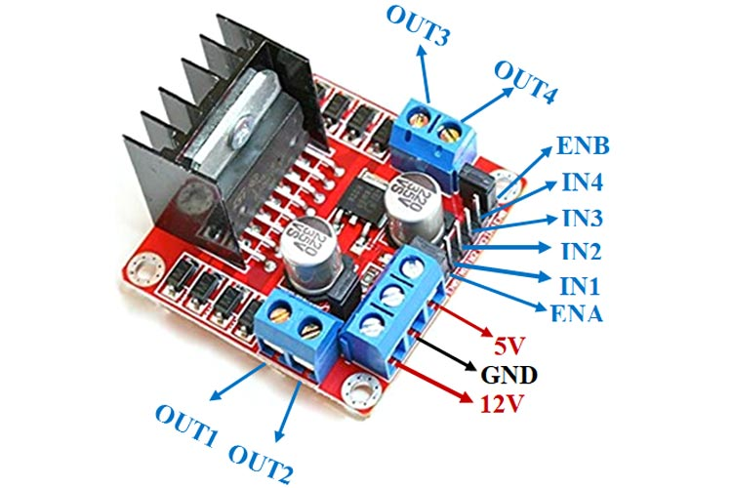

Figure . L298N Motor driver

**Pin configuration of L298N motor driver**

Table ‑ L298N Module Pin out Configuration

|  |  |
| --- | --- |
| **Pin Name** | **Description** |
| IN1 & IN2 | Motor A input pins. Used to control the spinning direction of Motor A |
| IN3 & IN4 | Motor B input pins. Used to control the spinning direction of Motor B |
| ENA | Enables PWM signal for Motor A |
| ENB | Enables PWM signal for Motor B |
| OUT1 & OUT2 | Output pins of Motor A |
| OUT3 & OUT4 | Output pins of Motor B |
| 12V | 12V input from DC power Source |
| 5V | Supplies power for the switching logic circuitry inside L298N IC |
| GND | Ground pin |

**How Motor Driver Module Works**

This module uses two techniques for the control speed and rotation direction of the DC motors. These are H-Bridge – For controlling rotation direction and PWM – For controlling the speed.

**H-Bridge Techniques**

L298n motor driver module uses the H-Bridge technique to control the direction of rotation of a DC motor. In this technique, H-Bridge controlled DC motor rotating direction by changing the polarity of its input voltage. An H-Bridge circuit contains four switching elements, like transistors (BJT or MOSFET), with the motor at the center forming an H-like configuration. Input IN1, IN2, IN3, and IN4 pins actually control the switches of the H-Bridge circuit inside L298N IC. We can change the direction of the current flow by activating two particular switches at the same time, this way we can change the rotation direction of the motor.

**Case 1**

When S1, S2, S3, and S4 all switches are open then no current goes to the Motor terminals. So, in this condition, the motor is stopped (not working).

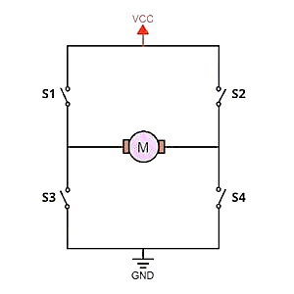

Figure . L298N Motor Driver Module Working of H-Bridge Case 1

**Case 2**

When the switch S1 and S4 are closed, then the motor left terminal is getting a positive (+) voltage and the motor right terminal is getting a negative (-) voltage. So, in this condition motor start rotating in a particular direction (clockwise).

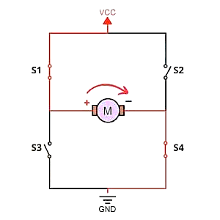

Figure . L298N Motor Driver Module Working of H-Bridge Case 2

**Case 3**

When S2 and S3 switches are closed, then the right motor terminal is getting a positive (+) voltage and the left motor terminal is getting a negative (-) voltage. So, in this condition motor start rotating in a particular direction (anticlockwise).

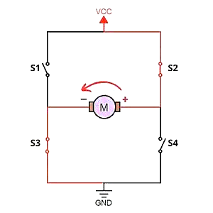

Figure . L298N Motor Driver Module Working of H-Bridge Case 3

**PWM (Pulse Width Modulation) Techniques**

L298n motor driver module uses the PWM technique to control the speed of rotation of a DC motor. In this technique, the speed of a DC motor can be controlled by changing its input voltage. Pulse Width Modulation is a technique where the average value of the input voltage is adjusted by sending a series of ON-OFF pulses. The average voltage is proportional to the width of the pulses, these pulses known as Duty Cycle. If the duty cycles higher, then the average voltage is applied to the DC motor (High Speed), and the lower the duty cycle, the less the average voltage being applied to the dc motor (Low Speed).

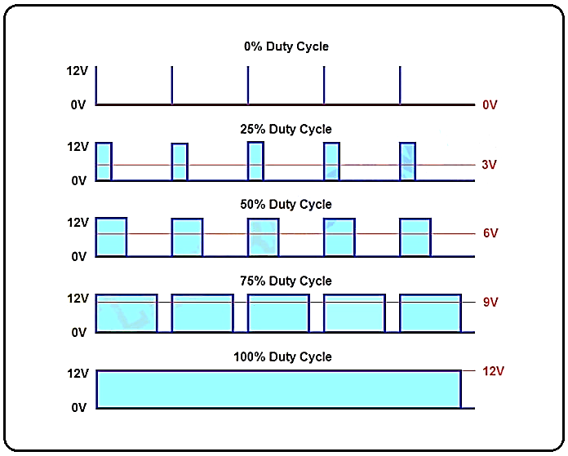

Figure . L298N Motor Driver Module Pulse Width Modulation (PWM) technique

#### DC Gear Motor

The most common motor for robotics is DC gear motor, which works by gearing down a fast DC motor to make the motor turn at a slower speed and give the motor a higher torque suitable for robot locomotion. A dc gear motor is basically a regular dc motor with a special gear box attached to the output shaft. Our robot electrical drive circuitry can control the dc gear motor to rotate the wheels of our robot for locomotion [14].

In our thesis we use two dc geared motor for driving the robot which is durable, easy, low-cost and affordable. These motors can be supply with 3VDC up to 6VDC.

**Use of gears:** Gears are generally used for the following different reasons

* To reverse the direction of the rotation
* To increase or decrease the speed of rotation
* To move rotational motion of different axis
* To keep the rotation of two axes synchronized
* To improve the speed of the wheel
* To increase or decrease the speed and or power

#### Chassis and Wheels

A vehicle without body is known as chassis. It is the backbone of vehicle on which total load of vehicle is applied. The components of vehicle like power plant, transmission system, Axils, wheels, electrical system are mounted on chassis. It is the main mounting for all the components including the body so it is called carrying unit of vehicle.

The main frame of the robot is the body which holds the motor, wheels and the batteries. We need to take care of the weight of the robot. In a robot with limited power supply (i.e. battery) the power to weight ratio has to be kept maximum. This can be done by limiting the weight of the chassis. Chassis can be made out of Wood, Plastic, Metal, Duct, and Plastic Pipes. The chassis design draw as the following [14].

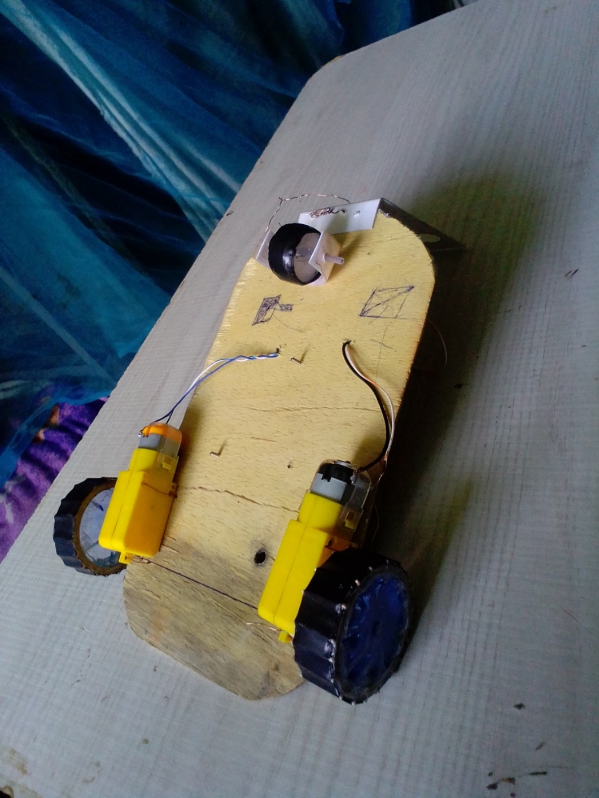

Figure . Chassis and Wheels of the prototype

#### Buzzer

Buzzers are electric sounding devices that generate sounds. Typically powered by DC voltage, they can be categorized as Piezo buzzer and magnetic buzzer. They come in different designs and uses as well, and based on that, they can produce different sounds [9].

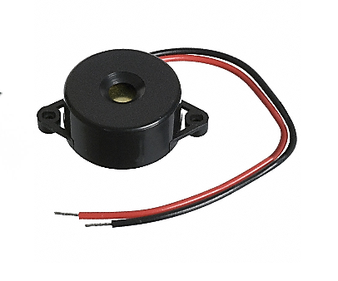

Figure . A Piezo buzzer

## Software component

### Arduino IDE

Arduino IDE is an open-source software, designed by Arduino.cc and mainly used for writing, compiling & uploading code to almost all Arduino Modules.It is an official Arduino software, making code compilation too easy that even a common person with no prior technical knowledge can get their feet wet with the learning process.It is available for all operating systems i.e. MAC, Windows, Linux and runs on the Java Platform that comes with inbuilt functions and commands that play a vital role in debugging, editing and compiling the code.

The main code, also known as a sketch, created on the IDE platform will ultimately generate a Hex File which is then transferred and uploaded in the controller on the board. The IDE environment mainly contains two basic parts: Editor and Compiler where former is used for writing the required code and later is used for compiling and uploading the code into the given Arduino Module. This environment supports both C and C++ languages.

The Arduino board is connected to a computer via USB, where it connects with the Arduino development environment (IDE). The user writes the Arduino code in the IDE, then uploads it to the microcontroller which executes the code, interacting with inputs and outputs such as sensors, motors, and lights [9].

Arduino IDE is used for our thesis to write the program that control the robot.

### Proteus Design Suite

Proteus Design Suite (designed by Labcenter Electronics Ltd.) is a software tool set, mainly used for creating schematics, simulating Electronics & Embedded Circuits and designing PCB Layouts. Proteus ISIS is used by Engineering students & professionals to create schematics & simulations of different electronic circuits. Proteus ARES is used for designing PCB Layouts of electronic circuits.

Proteus is a Virtual System Modelling and circuit simulation application. The suite combines mixed mode SPICE circuit simulation, animated components and microprocessor models to facilitate co-simulation of complete microcontroller based designs. Proteus also has the ability to simulate the interaction between software running on a microcontroller and any analog or digital electronics connected to it. It simulates Input / Output ports, interrupts, timers, USARTs and all other peripherals present on each supported processor [15].

Benefits

* Production-proven performance and superior quality of results
* Fully pipelined tape out flow to efficiently utilize expensive hardware resources
* The most accurate, easy to use, and flexible modeling environment
* manufacturing tools
* Best cost of ownership through the use of optimized general purpose hardware
* Core technology uniquely connects manufacturing information to design

Proteus design suite used for circuit simulation in our thesis to show the main principle behind the working principle of the line follower with obstacle detection but when it comes to visual display it has limitation of showing the robot overall movement.

Thus we only use Proteus Design Suite for the circuit simulation and we use Webots software for visual simulation.

### Webots

Webots is a professional mobile robot simulation software package. It offers a rapid prototyping environment, that allows the user to create 3D virtual worlds with physics properties such as mass, joints, friction coefficients, etc. The user can add simple passive objects or active objects called mobile robots. These robots can have different locomotion schemes (wheeled robots, legged robots, or flying robots). Moreover, they may be equipped with a number of sensor and actuator devices, such as distance sensors, drive wheels, cameras, servos, touch sensors, emitters, receivers, etc. Finally, the user can program each robot individually to exhibit the desired behavior. Webots contains a large number of robot models and controller program examples to help users get started [16].

Webots also contains a number of interfaces to real mobile robots, so that once your simulated robot behaves as expected, you can transfer its control program to a real robot like e-puck, DARwIn-OP, Nao, etc. Adding new interfaces is possible through the related sytem.

Webots is well suited for research and educational projects related to mobile robotics. Many mobile robotics projects have relied on Webots for years in the following areas:

* Mobile robot prototyping (academic research, the automotive industry, aeronautics, the vacuum cleaner industry, the toy industry, hobbyists, etc.)
* Robot locomotion research (legged, humanoids, quadrupeds robots, etc.)
* Multi-agent research (swarm intelligence, collaborative mobile robots groups, etc.)
* Adaptive behavior research (genetic algorithm, neural networks, AI, etc.).
* Teaching robotics (robotics lectures, C/C++/Java/Python programming lectures, etc.)

## Mathematical Modeling

### Kinematic Model of Line Following Robot with Obstacle Detection

Consider a simplified diagram of a mobile robot comprising of two wheels presented in Figure

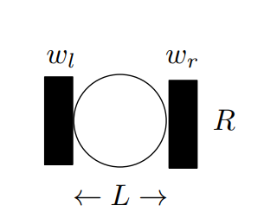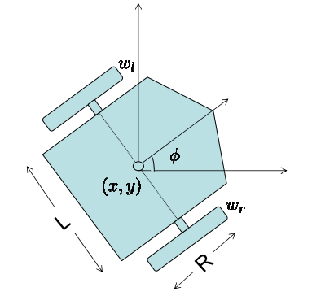

Figure . Kinematic Model of line follower robot with obstacle detection

The objective of this robot is to move in a planar region along some trajectory, so the states of this system are (x, y, ), where (x, y) correspond to the the location of the center point of the robot in a Euclidean plane and corresponds to the orientation of the robot. The robot contains two wheels each of which is equipped with a separate DC motor that controls its rotation. For this system, the inputs are going to be r and l , i.e., rates at which left and right wheel are turning. This robot is called differential drive because the steering of this system is based on difference in the turning rates of the two wheels. If , rl then the robot will travel in a straight line. If , rl, then the robot will turn in the direction of the wheel that is rotating at a slower rate. In order to model the trajectory followed by this robot, we have to track the movement of the center point of the robot which is (x, y). Given r, l, R, and L, the forward kinematic problem is to find the trajectory of the robot.The robot trajectory is given by the following set of equations

To control a differential drive mobile robot, the input to the system has to be r and l. However, when we are designing this system, it is inconvenient to think in terms of wheel rotations. A more natural set of control parameters is the speed at which our robot should move and its orientation. Therefore, instead of r and l, we design our system in terms of v and w, where v is the linear speed of the robot and w is the angular velocity, and a model that uses this set of parameters for is a unicycle model. According to this model,

Now we have two sets of equations for (, Equating both of them yields

Equations (3.9 & 3.10) allow us to design our system in terms of more convenient parameter, i.e. (v, ) and then use the values of these parameters to find the actual inputs to our system, i.e., (r, l). Once the input parameters (r, l) are computed that guarantee to drive the robot to the desire location, the next step is to find the motor parameters that will ensure that each wheel rotates at the desired rate.

From the modeling of fixed field DC motor, we know that and where is the torque produced by the motor and w1(t) is the angular velocity of the motor. Writing the loop equation

Where is the friction coefficient for the motor. The relationship between input and output   
of a two stage gear train is

where (*, , ,* ) are the input angular displacement, angular velocity, torque, and number  
of teeth of the first stage of the gear train, where as (*, , ,* ) are the output angular  
displacement, angular velocity, torque, and number of teeth of the second stage of the gear  
train.

# CHAPTER FOUR

# Result and Discussion

## Flow chart

Infrared detection

Data computation

Follow Black line

Read Ultrasonic distance value

Stop

Continue to follow black line

If distance <30 cm

Is the path clear?

YES NO

Buzzer ON

Figure . Flow chart

## General Operation of the Circuit

The basic operations of the line follower and obstacle detection robot are as follows:

The circuit contains Arduino microcontroller, two IR sensor, Ultrasonic sensor, L298N motor driver, two dc motors and buzzer. Arduino is the main controller that gives command according to the program the IR sensor sense the floor color and gives the data to the controller. The ultrasonic sensor detects the obstacle. The motor diver L298N used to control speed and direction of the two dc and the buzzer used for alarm system.

Capture black line position with IR sensors mounted at front end of the robot. For this a combination of IR LED’s and Photo Transistor called opt coupler is used. The line sensing process requires high resolution and high strength. Robot is to track the black line with any steering mechanism.

To achieve this, we use two motors governing wheels’ motion. It is powered by the Arduino Uno. The controller is powered by the Hex code program. It is operated in the frequency of the 11.05 MHZ. The ultrasonic sensor emit sound signal though the emitter if the obstacle is distance it reflect back and the receiver detect the reflected signal. If any obstacle read distance is less than 30 cm the controller command to stop the motors until the obstacle cleared from the path also if the ultrasonic read distance is less than 30 cm the alarm activated will give sound to indicate the obstacle is nearby or in the path of the robot the alarm stay activated unless the obstacle is cleared from the path. When the obstacle is clear from the path or the ultrasonic read distance is greater than 30 cm the motor activated and the robot start to follow the black line.

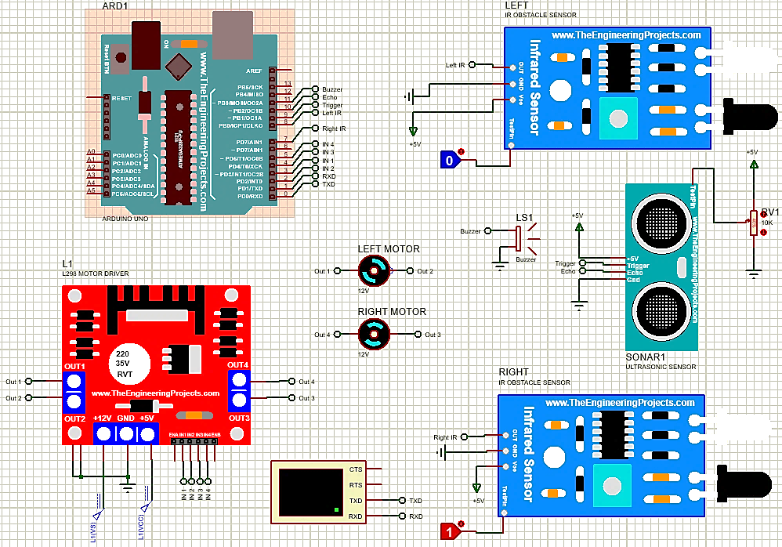

Figure . Overall circuit diagram

## Programming and Simulation

### Arduino Working Logic

The table below shows the working logic of the Arduino and IR sensor. The two IR sensors left and right respectively give 0 and 1 input to the Arduino. When the IR sensor is on the black line the emitted ray will be absorbed and gives 0 value and also on the white line the ray will reflect and received by the photodiode to give 1 value.

Table ‑ Working logic of an Arduino

|  |  |  |  |  |  |  |  |
| --- | --- | --- | --- | --- | --- | --- | --- |
| Conditions | IR sensor | | Input | | | | Command |
| Left | Right | 2 | 3 | 4 | 5 |  |
| 1 | 0 | 0 | 1 | 1 | 1 | 1 | Stop |
| 2 | 0 | 1 | 1 | 1 | 1 | 0 | Turn right |
| 3 | 1 | 0 | 1 | 0 | 1 | 1 | Turn left |
| 4 | 1 | 1 | 1 | 0 | 1 | 0 | Move forward |

### Proteus Simulation

Hence the circuit simulation is done by Proteus the first thing is getting all the required library for both Arduino and Proteus. After downloading the library then writing the program using Arduino. When finishing the programming the circuit development using Proteus is the next step. Final step is uploading the “hex” file to the Proteus and running for simulation.

The program code acts as the decision-maker embedded in the micro-controller deciding about the outputs for particular set of inputs. The program is coded using Arduino and is then compiled to form a “hex” file which can then be burnt into the Arduino. The output is also checked in simulation using Proteus.

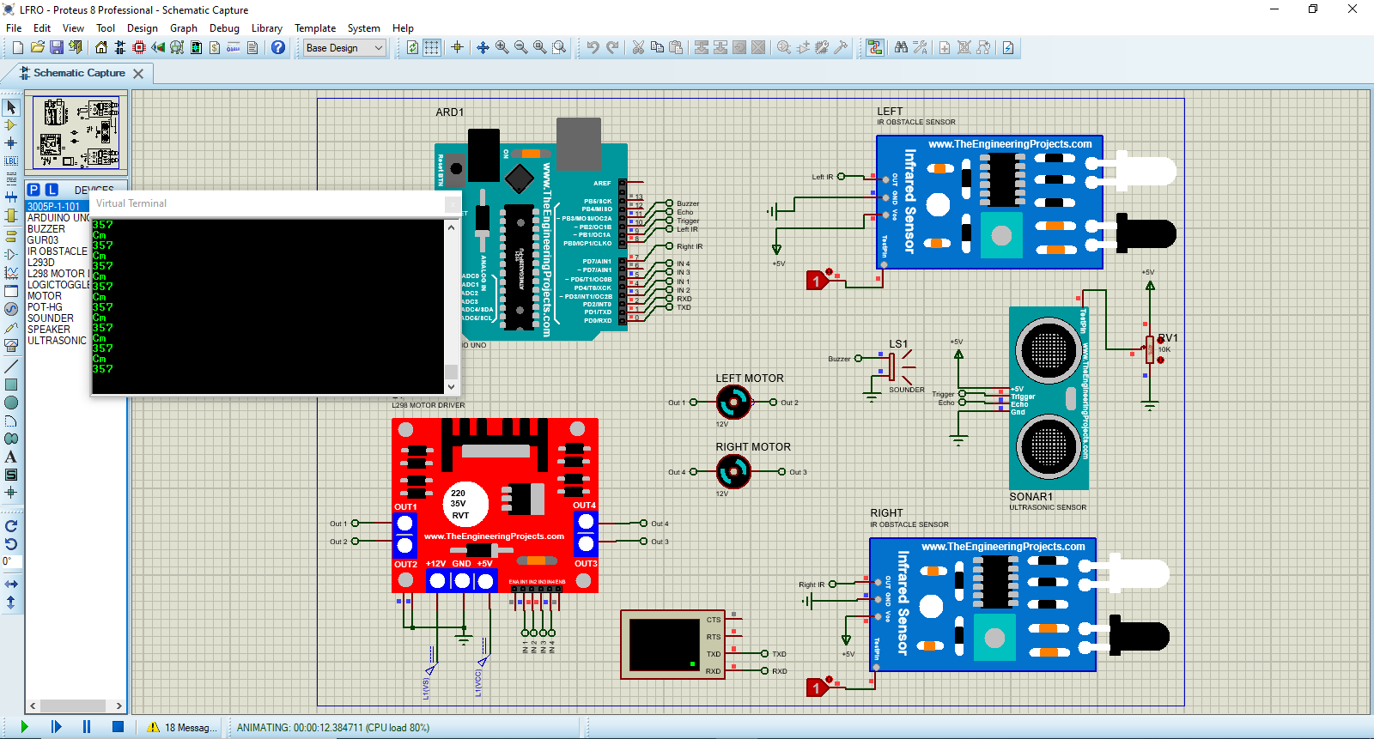

Figure . Proteus simulation

In the simulation the both motors run at equal speed when the left and right IR sensors on the white line or have 1 value. When the left IR sensor on the black line the left motor stop and the right motor only run at this time so the motor turn left direction. When the right IR sensor on black line the right motor stop and the left motor run to turn the robot in right direction.

When the obstacle distance is less than 30 cm the motors forced to stop and the buzzer will automatically give the alarm. Meanwhile if the distance is greater than 30 cm or obstacle is clear the motor start running to follow the black line as usual.

### Webots simulation

The visual simulation is very essential for robot simulation to show the overall movement of the robot. For simulation our thesis we use Webots R2021b e-puck library that is presented in the Webots library.

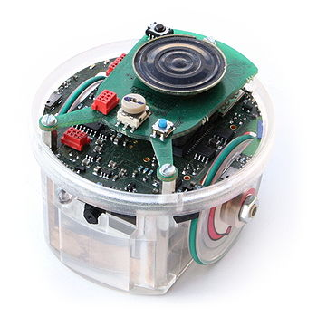

Figure . E-puck

After adding the e-puck library it consists of the required distance sensors the next step designing of the path and obstacles with appropriate scale.

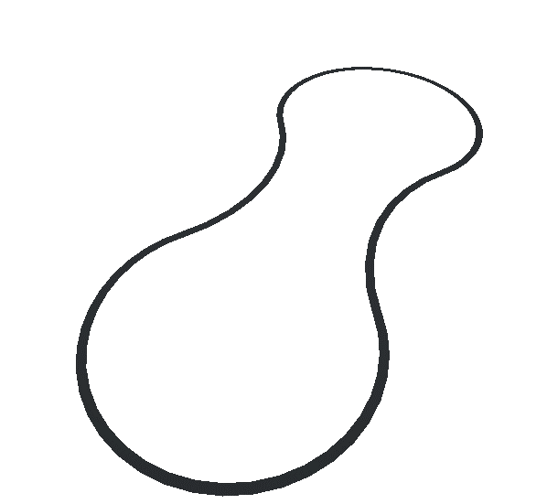

Figure . Path of the robot

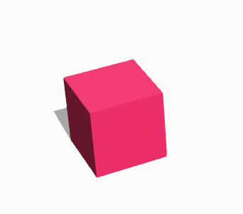

Figure . Obstacle

Finally, when the path and obstacle design finished we just have to upload the controlling code to the microcontroller rebuild the robot automatically start running.

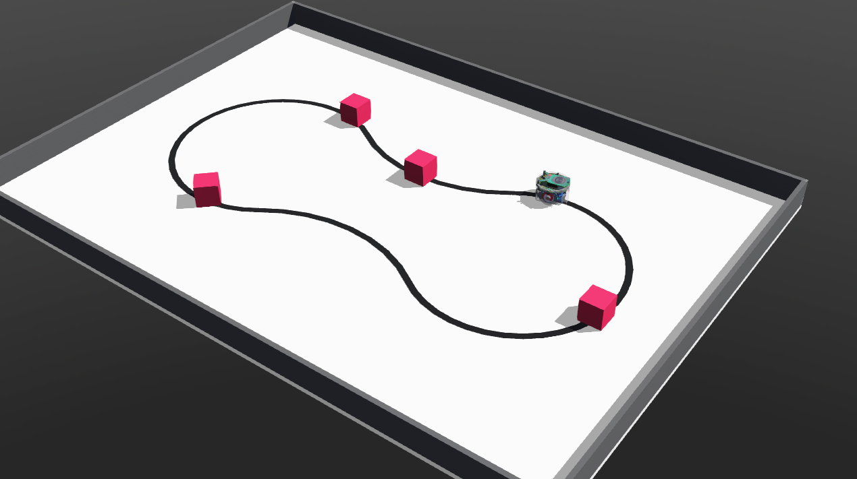

Figure . Webots simulation

## Implementation of the project

### Component used

Table ‑ Component used

|  |  |  |
| --- | --- | --- |
|  | Name | Qty. |
| 1 | IR sensor | 2 |
| 2 | Ultrasonic sensor(HC-SR-04) | 1 |
| 3 | Arduino UNO(Rev 3) | 1 |
| 4 | Motor driver(L298N) | 1 |
| 5 | Dc motor | 2 |
| 6 | Buzzer | 1 |
| 7 | Battery | 1 |
| 8 | Jumper wires | - |
| 9 | Chassis | 1 |
| 10 | Wheels | 2 |
| 11 | Caster wheel | 1 |
| 12 | Bread board | 1 |

For implementation we have used L293d motor driver rather L298n (which is used in the simulation) because of difficulties of getting it.

Here..........  
Two IR sensors are connect Pin 8 and Pin 7 in Arduino.  
Left IR sensor:-output is connect to Pin 7 of Arduino  
Right IR sensor:-output is connect to Pin 8 of Arduino.  
For ultrasonic distance sensor

L293d motor driver:-  
2, 3, 4, and 5 pin of Arduino are connect to the motor driver.  
Pin 2 of Arduino connect Pin 2 of L293d  
Pin 3 of Arduino connect to Pin 3 of L293d  
 Pin 4 of Arduino connect to Pin 4 of L293d  
Pin 5 of Arduino connect to Pin 4 ofLl293d  
and vcc is connect to +5v and gnd is connect gnd.   
power supply will be from battery 9v or power bank

Ultrasonic pin of trigger and echo connect to Arduino pin of 9, 10 respectively

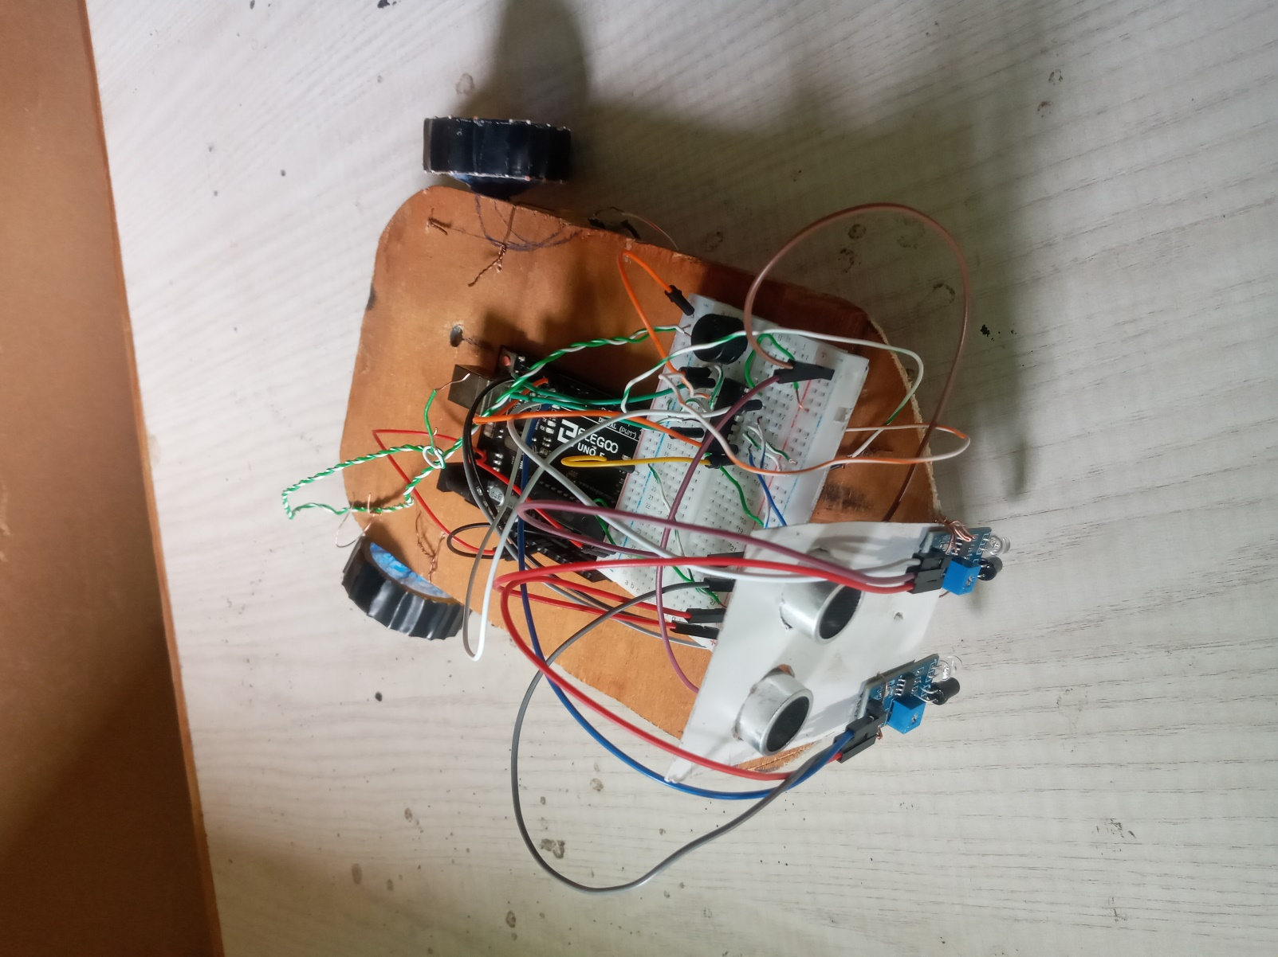

Figure . Line following robot with obstacle detection

# CHAPTER FIVE

# CONCLUSION AND RECOMMENDATION

## Conclusion

In this thesis we have learned the basics of electronic circuits, motors, ultrasonic sensor, IR sensors, motor driver, basics of Arduino and programming into Arduino and Proteus simulation. Line follower with obstacle detection robot works based on IR sensor, ultrasonic sensor, motor driver and the dc motor with the Arduino program. The IR sensor contains comparator, OP amplifier, LED receiver and transmitter. The robot moves and works according to the IR sensor detection of the line. There are two IR sensor with four cases (turn left, turn right, forward and stop). Also it has ultrasonic sensor to detect obstacle and give alarm with the help of buzzer.

Generally, as we have seen from the simulation result the robot has the ability to go on black line forward, turning to left and right and it can stop when obstacle is detected.

## Recommendations

This thesis leads to several recommendations concerning the line follower and obstacle detection the recommendation to the future work:

Using an artificial intelligence algorithm such as neural network initiative

* Use Stepper motors has the advantage of precise angular movement.
* Using Wi-Fi control, exclusive support dual control system, used in Apple and Android products.
* Use timer to know the duration of the robot turns, and use an angle detection sensor to know how much angle the robot turns.

# References

|  |  |
| --- | --- |
| [1] | Mark W. Spong, Seth Hutchinson, and M. Vidyasagar, Robot Dynamics and Control, 2004. |
| [2] | J. J. Craig, Introduction to Robotics mechanics and control, 2018. |
| [3] | A. Pathak, "DeepAI," 23 May 2020. |
| [4] | T. Faiza and L. Susmita, "Obstacle Avoiding Robot," *Global Journal of Researches in Engineering: H,* p. 24, 2017. |
| [5] | Q. T. S and K. R. T. N. E. Syed, "Design and Implementation of Line Follower," vol. Volume 11, no. 4, April-2020. |
| [6] | S. V. Anupoju, B. Manasa and K. R. k, "Design to Implementation of A Line Follower Robot Using 5," vol. Vol. 3, no. Issue 1, January – 2019. |
| [7] | M. T. D. O. Omer Gumus, "The use of computer controlled line follower robots in public," 2016. |
| [8] | M. I. H. Md. Majedur rahman, "Autonomous Line Robot Using PIC16F676," *Journal of Electrical Engineering and Electronic Technolong,* 2017. |
| [9] | T. Pan and Y. Zhu, Designing Embedded System With Arduino, 2018. |
| [10] | J. D. Vincent, Fundamentals of Infrared Detector Operation and Testing, Eds., 1993. |
| [11] | A. Hughes, Electric Motors and Drives, Leeds: Elsevier Ltd., 2006. |
| [12] | G. Turan and W. Jim, Power Electronics Handbook, Ed, 2006. |
| [13] | P. Tianhong and Z. Yi, "Designing Embedded Systems with Arduino," in *Designing Embedded Systems with Arduino A Fundamental Technology for Makers*, Singapore, Springer Nature Singapore Pte Ltd, 2018, p. 3. |
| [14] | S. L. a. D. V. L. Jetto, Localization of a wheeled mobile robot by sensor data fusion based on a fuzzy logic adapted Kalman Filter, 1999, pp. 763-771. |
| [15] | Z. R. JING, PROTEUS schematic simulation and PCB design example fine solution, ‎ Electronic Industry Press, 2016. |
| [16] | T. Gomi, Webots User Guide, Cyberbotics Ltd, 2014. |

**Appendix**

#include <Ultrasonic.h>

#include <ping.h>

Ultrasonic ultrasonic (9, 10);

const int right_irsensor = 7;

const int left_irsensor = 8;

const int motor_rightBack = 2;

const int motor_leftFront = 5;

const int motor_leftBack = 4;

const int buzzer = 11;

int x;

int y;

void setup()

Serial.begin(9600);

for(x = 2; x<6; x++){

pinMode(x, OUTPUT);

}

for(y=7; y<9 ; y++){

pinMode(y, INPUT);

pinMode(buzzer, OUTPUT);

}

}

void loop() {

int right_sensor = digitalRead(right_irsensor);

int left_sensor = digitalRead(left_irsensor);

int reading = ultrasonic.read();

Serial.println("Cm");

Serial.println(reading);

delay (100);

if(reading>30){

if(right_sensor == HIGH && left_sensor == LOW){

left();

}

if(right_sensor == LOW && left_sensor == HIGH){

right();

}

if(right_sensor == LOW && left_sensor == LOW){

yay();

}

if(right_sensor == HIGH && left_sensor == HIGH){

forward();

}

else{

yay();

}

}

void right(){

digitalWrite(motor_rightFront, LOW);

digitalWrite(motor_rightBack,LOW );

digitalWrite(motor_leftFront, LOW);

digitalWrite(motor_leftBack, HIGH);

void left()

digitalWrite(motor_rightFront, LOW);

digitalWrite(motor_rightBack, HIGH);

digitalWrite(motor_leftFront, LOW);

digitalWrite(motor_leftBack, LOW);

}

void forward(){

digitalWrite(motor_rightFront, LOW);

digitalWrite(motor_rightBack, HIGH);

digitalWrite(motor_leftFront, LOW);

digitalWrite(motor_leftBack, HIGH);

}

void stop(){

digitalWrite(motor_rightFront, LOW);

digitalWrite(motor_rightBack, LOW);

digitalWrite(motor_leftFront, LOW);

digitalWrite(motor_leftBack, LOW);

tone(Buzzer, 1000);

delay(100);

noTone(buzzer);

delay(10);

}

void backward(){

digitalWrite(motor_rightFront, HIGH);

digitalWrite(motor_rightBack, LOW);

digitalWrite(motor_leftFront, HIGH);

digitalWrite(motor_leftBack, LOW);

}